Example One (Low Complexity)
1.) Which is a power delegated to the national government?
A. conducting elections
B. establishing courts
C. coining money
D. taxing citizens
CLICK HERE FOR ANSWERS & EXPLANATIONS

Example Two (Moderate Complexity)
2.) Which statement describes a similarity between the state and the federal governments under the U.S. Constitution?
A. Both levels of government allow for the election of judges.
B. Both levels of government have the power to ratify treaties.
C. Both levels of government allow for the collection of taxes.
D. Both levels of government have the power to appoint ambassadors.
CLICK HERE FOR ANSWERS & EXPLANATIONS

Example Three (High Complexity)
The map below describes the number of people on death row in the United States as of 2012.
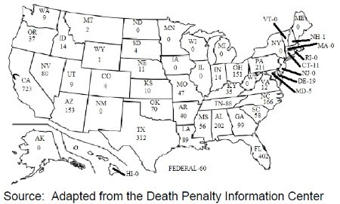
3.) What constitutional relationship does the map illustrate?
A. enumerated powers
B. concurrent powers
C. delegated powers
D. reserved powers

