SCPS - Civics EOC Review Guide
Name of Document | How it Laid the Foundation for American Democracy
Magna Carta | Limited Power of the monarchy, made its citizens have a trial by jury, eliminated the power of the king to have unjust taxes.
Parliament | Legislative branch of Great Britain- the idea of representative government
English Bill of Rights | Limits the power of the monarchy (limited government) – Idea that people have rights and they are recorded.
House of Burgesses | Legislature in the New World – In Virginia, 1st colonial attempt at a government system.
Mayflower Compact | 1st written colonial constitution- social contract of the Pilgrims – direct democracy

Event | How this caused the American Revolution
French and Indian War | War between France and Great Britain for supremacy of land. Caused colonial heavy taxation-led to American Revolution.
Stamp Act | British law placing a tax on printed colonial matter: Paper products
Quartering Act | British 1760s law requiring colonists to supply the basic needs of British soldiers – 3rd amendment protects Americans from this.
Declatory Act | British act of Parliament declaring its right to tax and legislate over the colonies without colonial representation. (“No taxation without representation)
Tea Act | Forced colonist to buy tea only from the British East Indian Company.
Boston Tea Party | Protest by the Sons of Liberty against the British. Colonists dressed as Indians and threw tea overboard.
Common Sense | Pamphlet written by Thomas Paine that called for independence from Great Britain.
Author of the Declaration of Independence | Thomas Jefferson – John Locke’s ideas of: Life, Liberty and Property.  Signed: July 4, 1776
Main Ideas of the Declaration of Independence | - Unalienable Rights- Life, liberty, and pursuit of happiness.  - Grievances against the King of England. Listed the many abused the colonists suffered under the British king.  - Rights to revolt because the treatment they had received under British rule contradicted the purpose of Government.
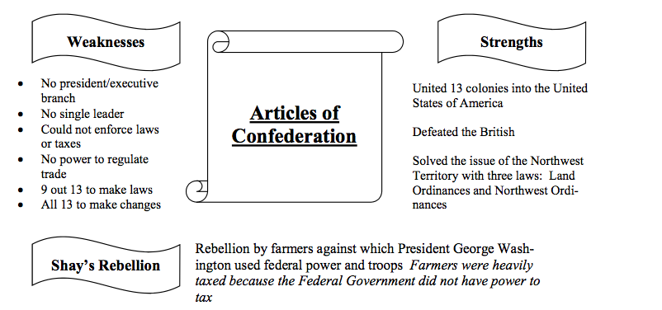

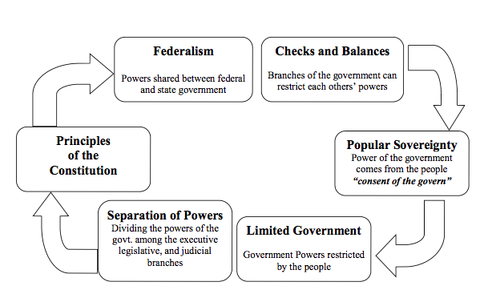

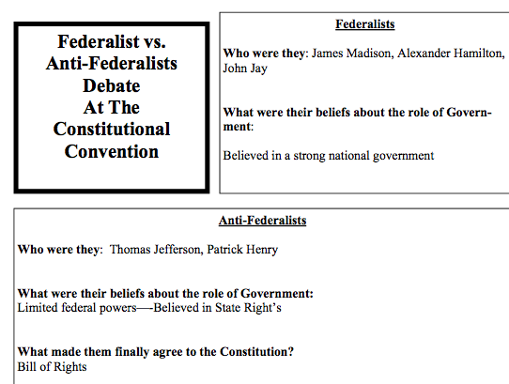

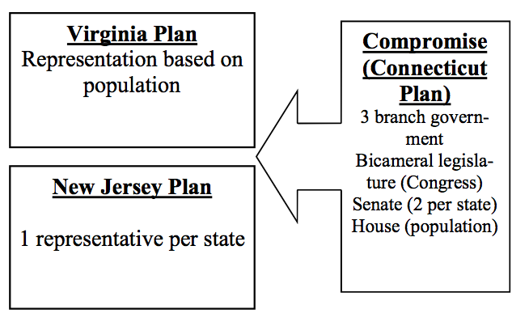

Amendment that address the President:  20th: Inauguration date of the President  22nd: Limit president to two terms  25th: Presidential succession Act | Amendments that Address Voting Rights:  15th: Minority groups gain suffrage  19th: Women gain suffrage  26th: Voting age changed from 21 to 18 (Vietnam War)
Post Civil War Amendments  13th: Abolish slavery  14th: Citizenship and due process of law on state level  15th: Minority groups gain suffrage | Amendments that Address Rights of the Accused  4th: Privacy Amendment (Search Warrant)  5th: Eminent domain, grand jury, self-incrimination, double jeopardy, due process  6th: Right to a speedy and public trail; Right to an attorney  8th: Protection from cruel and unusual punishment, excessive bail.

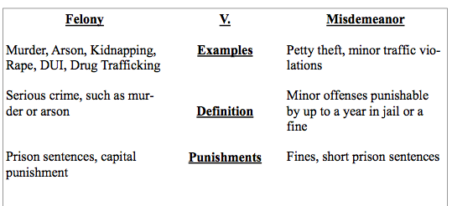
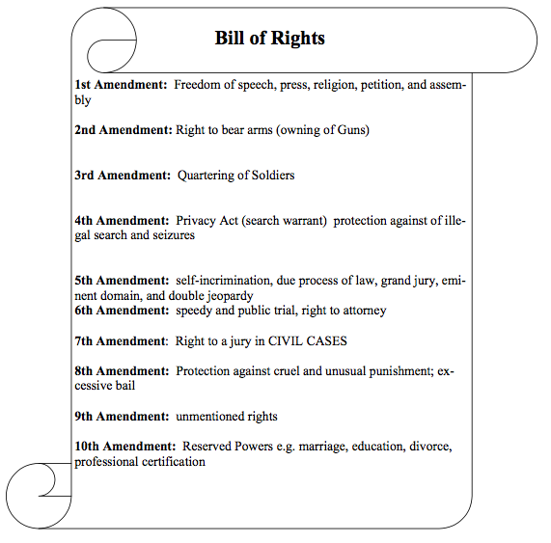

Levels of Court Systems
Levels of Government

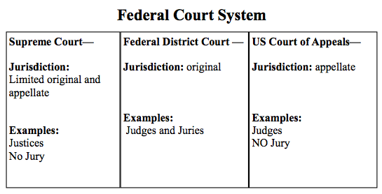

The Three Branches
Branch | Members of the Branch | Role
Legislative Branch | Congress  (House of Representatives and Senate) | Makes Laws
Executive Branch | President  Executive Office of President Cabinet | Enforce Laws
Judicial Branch | Supreme Court and Federal Court System | Interpret Laws

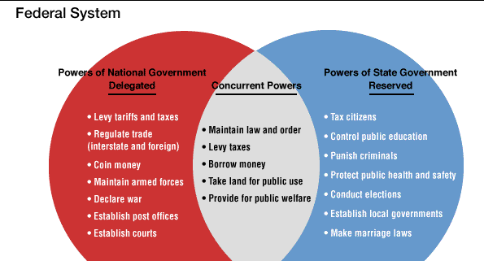

7 roles of the president
Chief executive | Enforces laws
Chief diplomat | Handles foreign policy
Party leader | Head of his or her political party
Commander-in-chief | Leader of the military
Head of state | Represents the US with foreign leaders and ceremonial leader
Economic leader | Implementing the nation’s economic policies
Chief legislator | Propose legislation (laws) to congress

Checks and Balances
Judicial Checks on Executive | Can declare presidential actions unconstitutional
Judicial Checks on Legislative | Can declare acts of legislature unconstitutional
Executive Checks on Legislative | Can veto legislation
Executive Checks on Judicial | Can appoint Supreme Court Justices
Legislative Checks on Executive | Impeachment process, can override veto, and reject appointments, can refuse to approve treaties.
Legislative Checks on Judicial | Can impeach judges  Can reject appointment of judges

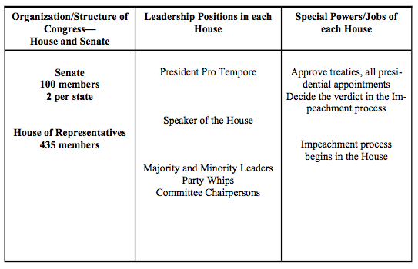

Supreme Court Cases

Name of Case | Constitutional Principal | Why the Decision is Important
Marbury vs. Madison | Separation of powers in the Judicial Branch | Established Judicial Review  Demonstrates the power of the Judicial Branch
Plessy vs. Ferguson | Equality rights of minority groups  (14th Amendment) | It is okay to separate the races “SEPARATE BUT EQUAL”
Brown vs. Board of Education | Equality rights of minority groups  (14th Amendment) | Separate but equal is unconstitutional  Segregation ends in the public school system
Gideon vs. Wainwright | Civil liberties and rights of the Accused  (6th Amendment) | 6th Amendment right to an attorney if you cannot afford one.
Miranda vs Arizona | Criminal Procedures; Rights of the accused and civil liberties  (5th Amendment) | 5th Amendment: Self-Incrimination  Miranda Rights: Right to remain silent….
Tinker vs Des Moines School Distric | Civil Liberties  (1st Amendment) | 1st Amendment: Freedom of speech  Symbols are considered freedom of speech
United States vs Richard Nixon | Separation of Powers (Article 6 of the U.S. Constitution) | President’s Executive Privilege can not be used to conceal a crime.  Rule of law!
Hazelwood School District vs Kuhlmeier | Rights of students, Freedom of press  (1st Amendment) | School publications can be censored
Bush vs Gore | Electoral College | The president is selected through the electoral college and not the popular vote

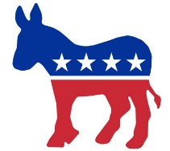
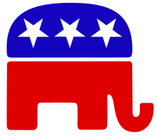
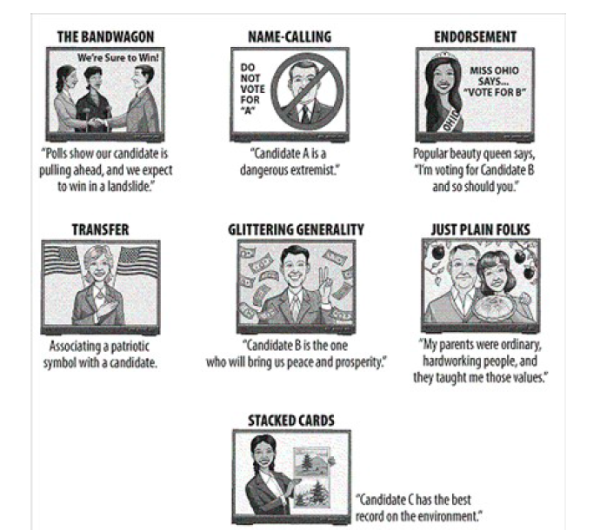

Republicans | Democrats
- Conservative  - Red  - Elephant  - Less Government Control  - Lower Taxes | - Liberal  - Blue  - Donkey  - More Government Control  - Higher Taxes

